**REACT JS FRAMEWORKS & LIBRARIES GUIDES**

1. Create React app
   1. Npx create-react-app <name of app>
2. Create function

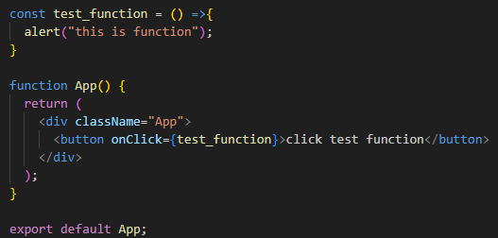

1. Create function with parameter

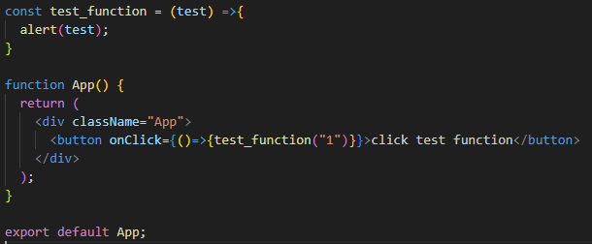

1. Get value from input

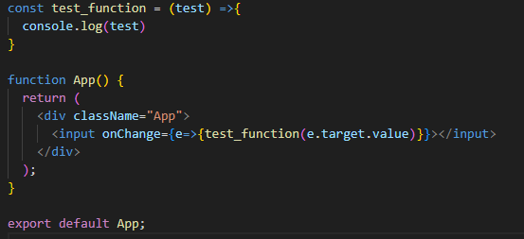

1. Using useState

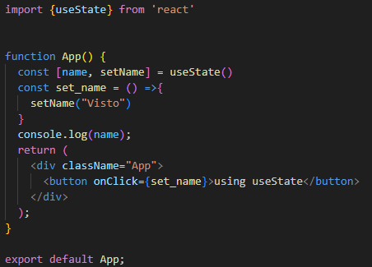

1. Add data to useState

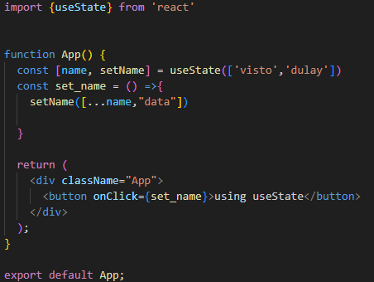

1. Create Components

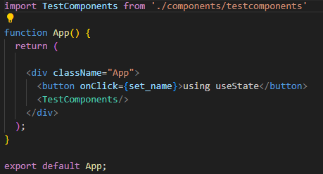

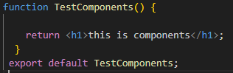

1. Create Props

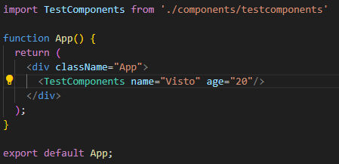

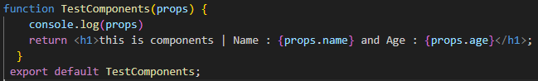

1. Send Http get request using Axios (<https://axios-http.com/docs>)

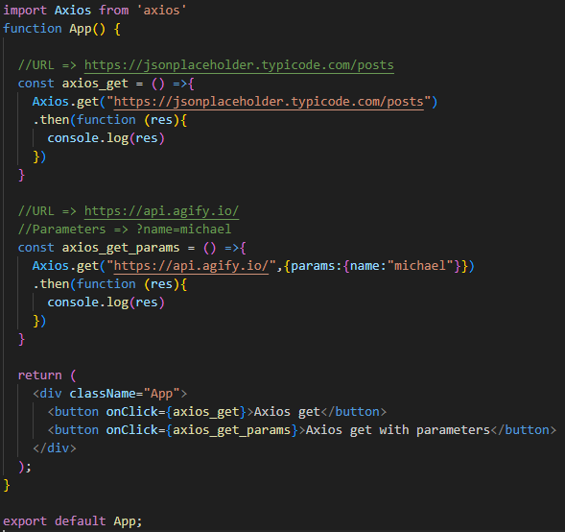

1. Send Http post request using Axios

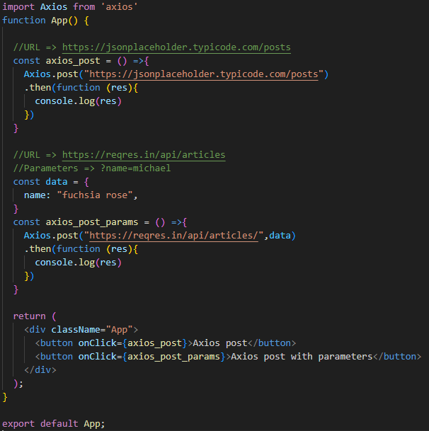

1. Array Mapping

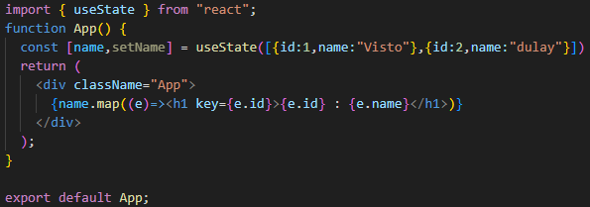

1. File Upload and File Handling
2. Custom Header
3. JSON